New Minimalism Interior Design
Contemporary Minimalism – not just the absence of materialistic objects, but the careful selection of meaningful items that helps your physical or mental well-being.
Minimalism – keeping objects that have function in life or provides regular happiness

Minimalism was a direct reaction against abstract expressionism. The term came from the 1960s New York, inspired by the clean, functional designs of modernistic art. The Bauhaus School in Weimar in the 1920s created conceptual designs with the least possible materials, this idea predating the term ‘minimalism’ by many years.

- Less is more
- Material and textural focus
- Wabi-sabi, the theory that there is beauty in imperfection
- Clean geometric lines replaced by primitive shapes and sculptures
- Natural materials and local design
- Environmental issues and sustainability kept in mind

Features of this include –
- Woods, stones, and raw material
- Browns, pastels, whites, greys
- Off whites, warm tones
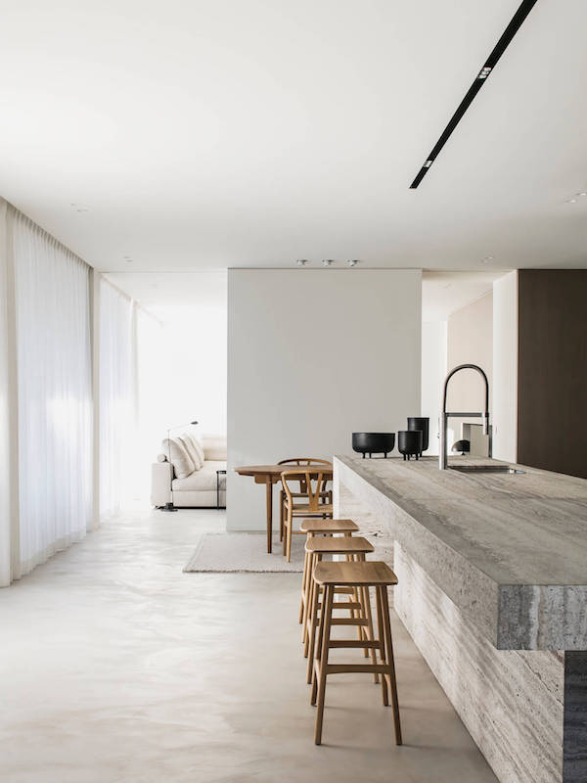
- Scandanavian aesthetics
